Synopsis Report

**Topic:- GOLD’S GYM**

**NAME OF THE CANDIDATE(S)**

SECTION-K19PA ROLL NO.

HARSH GANDHI - 45

JAYESH PALIWAL- 52

AYUSH RANJAN - 61



**Department of Intelligent Systems**

**School of Computer Science and Engineering**

**Lovely Professional University, Jalandhar (2020-21)**

**Submitted to:- Dr. Dhanpratap Singh**

**SYNOPSIS:-**

Introduction :

This project is aimed at website called **Gold's Gym International, Inc.** which is an American chain of international co-ed [fitness centres](https://en.wikipedia.org/wiki/Fitness_center) (commonly referred to as [gyms](https://en.wikipedia.org/wiki/Gym)) originally started by [Joe Gold](https://en.wikipedia.org/wiki/Joe_Gold) in [Venice Beach, California](https://en.wikipedia.org/wiki/Venice,_Los_Angeles). Each gym offers a variety of cardio and strength training equipment as well as group exercise programs. Its headquarters have since relocated to [Dallas](https://en.wikipedia.org/wiki/Dallas).

Objective of construction :

Gold's Gym enjoys a strong demand for their services, but like many businesses today, they face particular challenges when it comes to ensuring that they continue to keep and attract customers. They also understand that in this age of Internet technology, their target market is increasingly becoming sophisticated and time-hungry, expecting information to be accessed at the touch of a button.

To address these challenges, Gold's Gym commissioned The Website Marketing Group to redesign their website. The aim is to increase customer engagement, connect with their customers and enable the community to be always up-to-date with their favourite gym's latest news and information.

Scope of project :

This system will allow people to know about Fitness and one can also add into the new members of our community. Gold’s Gym India is acknowledged for its unrivalled success in providing the finest equipment and fitness knowledge available to help its members achieve their individual potential. It follows a globally proven fitness training module with state-of-the-art infrastructure and delivery methodology and continuous up gradation through training programs. With certified trainers and nutritional counselling, Gold’s Gym provides a comprehensive approach to the health and well-being of its member.

Modules Included :

**Home** :- This page contains matter of what this website is all for containing slideshow of the images of the inside of the gym. It also contain the description of the packages i.e., Monthly, Quarterly, Half Yearly, Annually.

It also contain the the gallery of the Gold’s Gym equipment’s.

It also contain the common questions asked about Gold’s Gym i.e., FAQ’s.

**Get Started** :- This image contains the information of the locations of our gyms in different parts India.



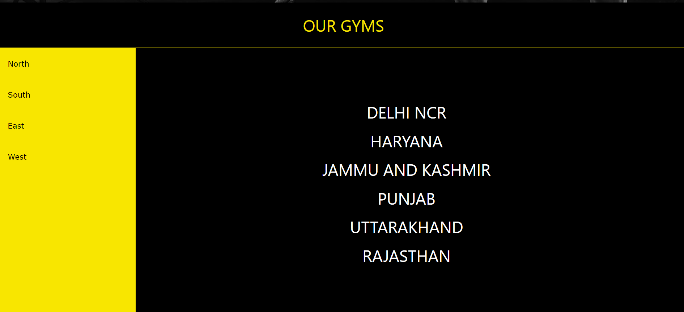

**About Us** :-This webpage contains the information about Gold’s Gym. It also contain the history of gold’s Gym in India.

It also contain the achievements and awards received by Gold’s Gym.

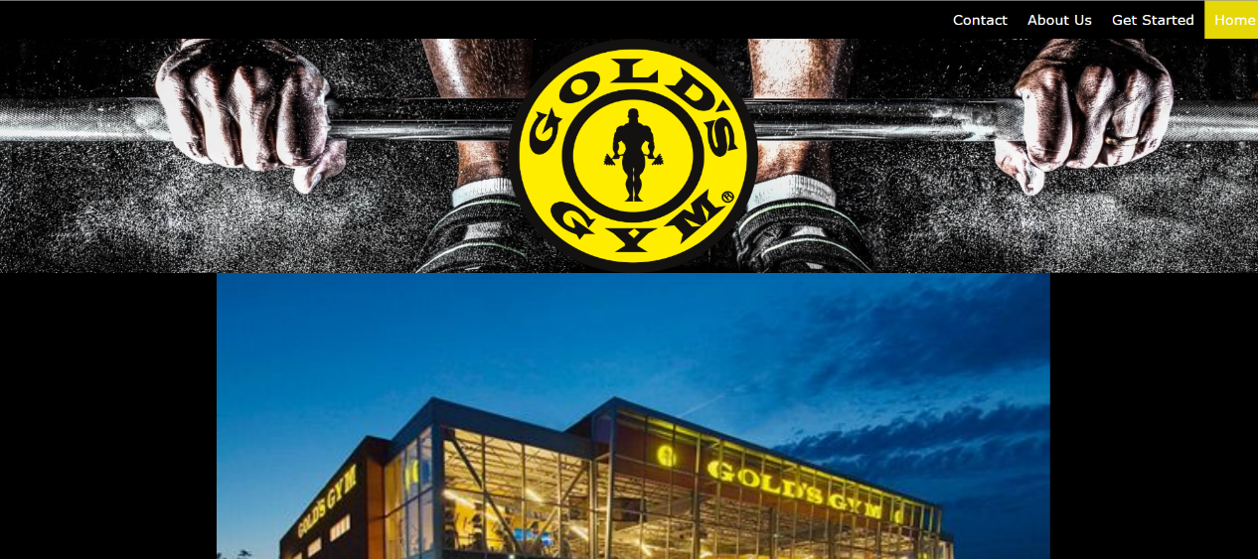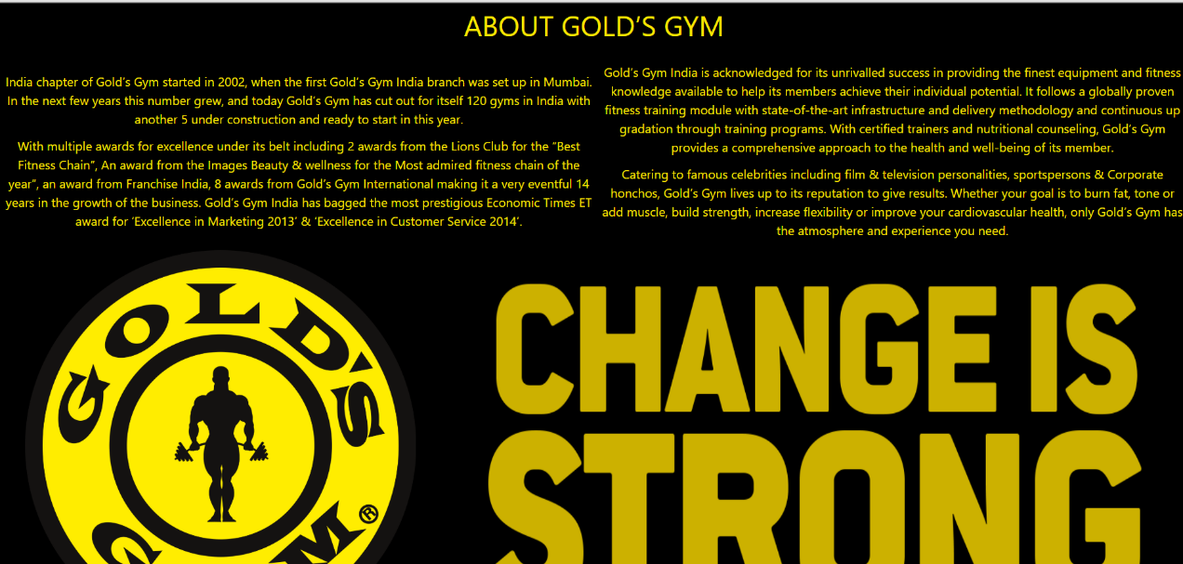

**Contact Us** :- This webpage contain the information of our offices and the way to contact us.

It also contain the form where we can ask anything to the Gold’s gym.

